U18CO018

Shubham Shekhaliya

Sub: MIT

Lab: Assignment-4

1 Write a program to load the data byte A8H in register C. Mask the high-order bits(D7-D4), And display the low-order bits (D3-D0) at an output port.

Code:-

mvi c ,0A8H

mov a,c

; for the last 4 bit do and with 0FH

mvi b,00FH

ana b

out 01H

hlt

Output:-

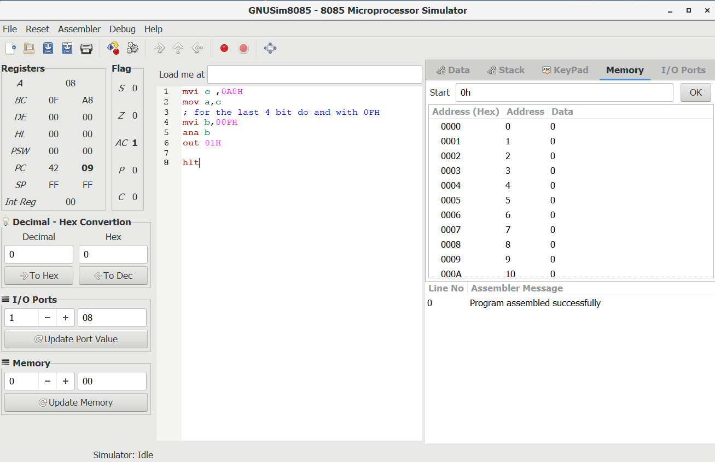

2 Write a program to load the data byte 8EH in register D and F7H in register E.Mask the high-order bits (D7-D4) from both the data bytes, Exclusive-OR the low-order bits (D3-D0) and display the answer.

Code:-

mvi D,8EH

mvi E,0F7H

mvi b, 0FH

mov a,d

ana b

mov d,a

mov a,e

ana b

mov e,a

mov a,d

xra e ; accumulator contains the xor of the both number (LSB)

;at port 1

out 01H

hlt

Output:-

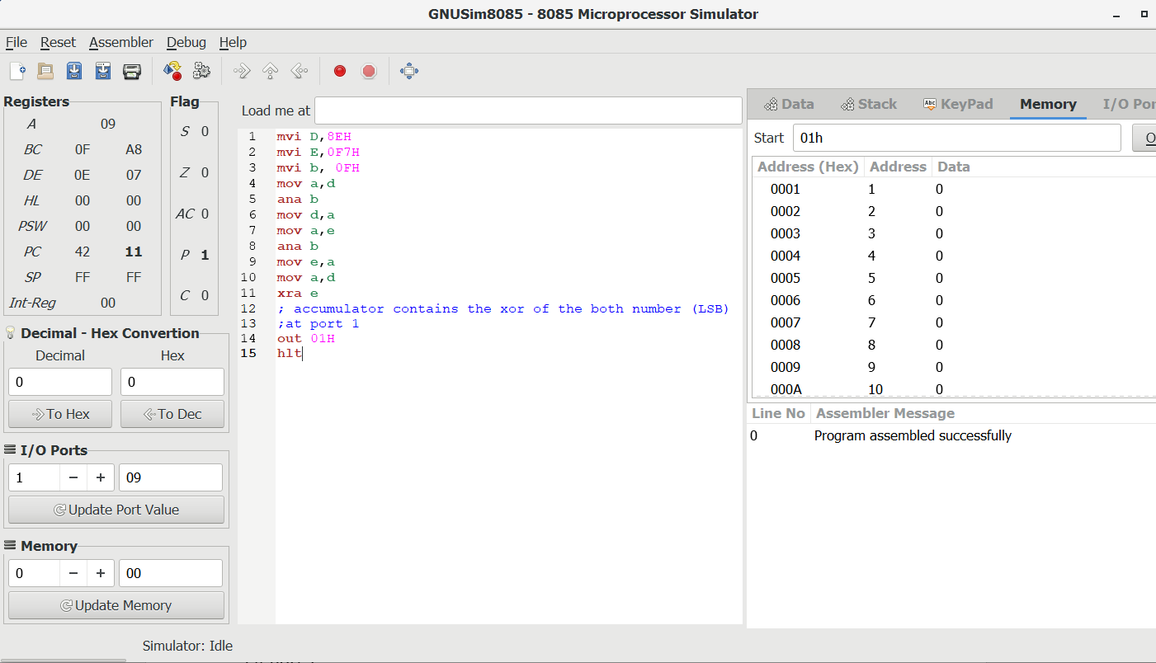

3 Write a program to load the bit pattern 91H in register B and 87H in register C. Mask all the bits except D0 from registers B and C.

Code:-

mvi b,91H

mvi c,87H

mvi d,01H

mov a,b

ana d

mov b,a ; register b contain the answer

mov a,c

ana d

mov c,a ; register c contain the answer

hlt

Output:-

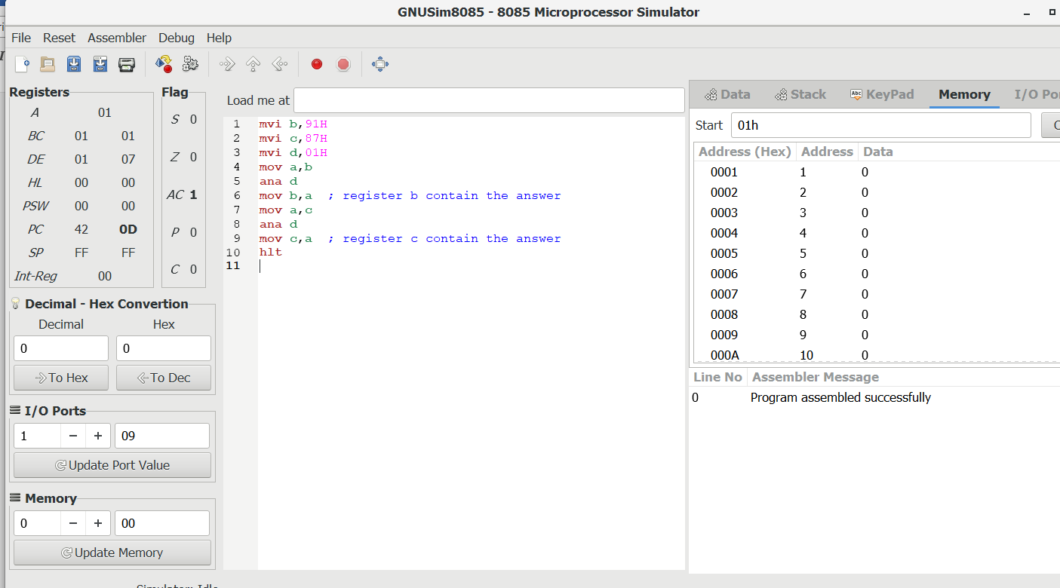

4 Write a program to clear the CY flag, to load number FFH in register B, and increment B. If the CY flag is set, display 01 at the output port, otherwise, display the contents of register B.

Code:-

xra a ;clear the cy flag

mvi b,0FFH

inr b ;it doesn't affect CY flag

jnc show ;if carry then show 01H

mvi a,01H

out 01H

jmp end

show: mov a,b

out 01H

end: hlt

Output:-

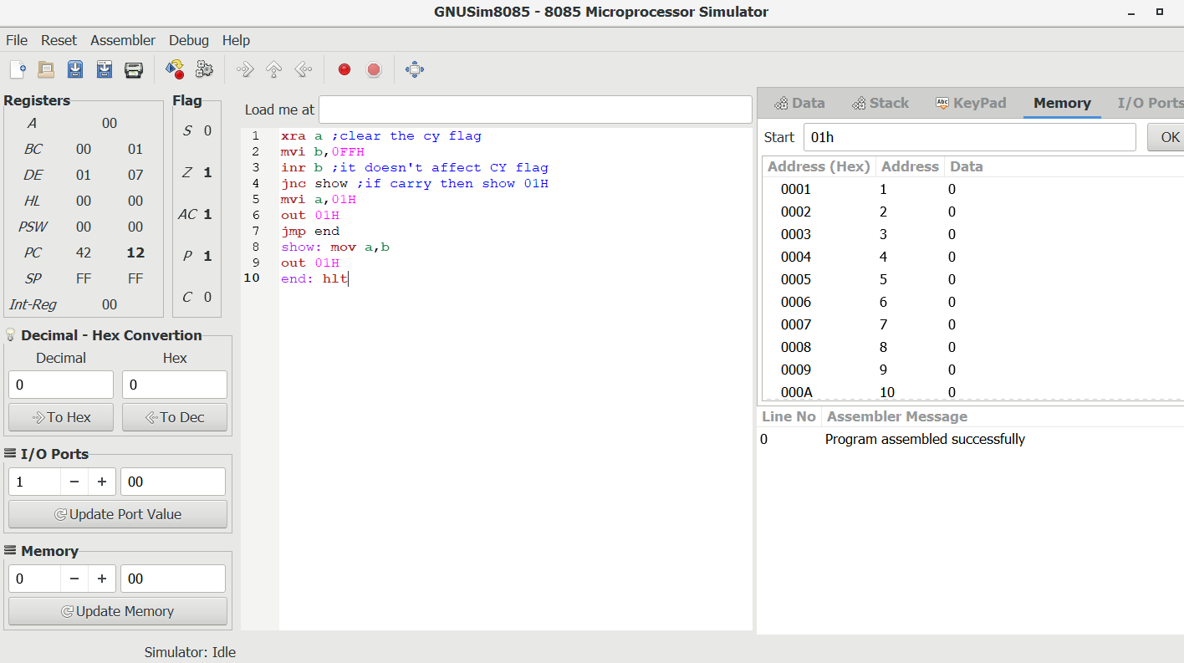

5 Write a program to mask lower bit of an 8 bit number.

Code:-

mvi a,0A5H

ani 0F0H ;mask lsb and accumulator contains result

hlt

Output:-

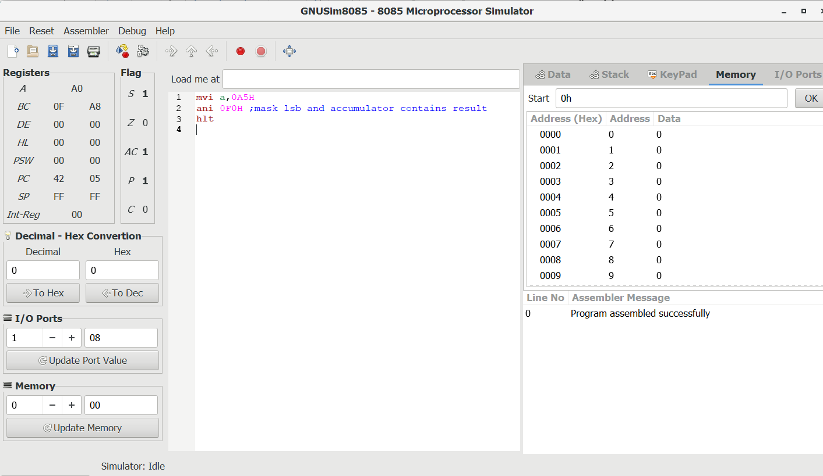

6 Write a program Load two unsigned numbers in register B and register C respectively. Subtract C from B. If the result is in 2’s complement, convert the result in absolute magnitude And display it at PORT 1, otherwise, display the positive result. Execute the program.

Code:-

mvi b,042H

mvi c,069H

mov a,b

sub c

jnc display ;if ans -ve then it will produce carry

cma ;for getting magnitude one's complement

inr a ; two 's complement

display: out 01H

hlt

Output:-

1. For Set1:B=42H,C=69H

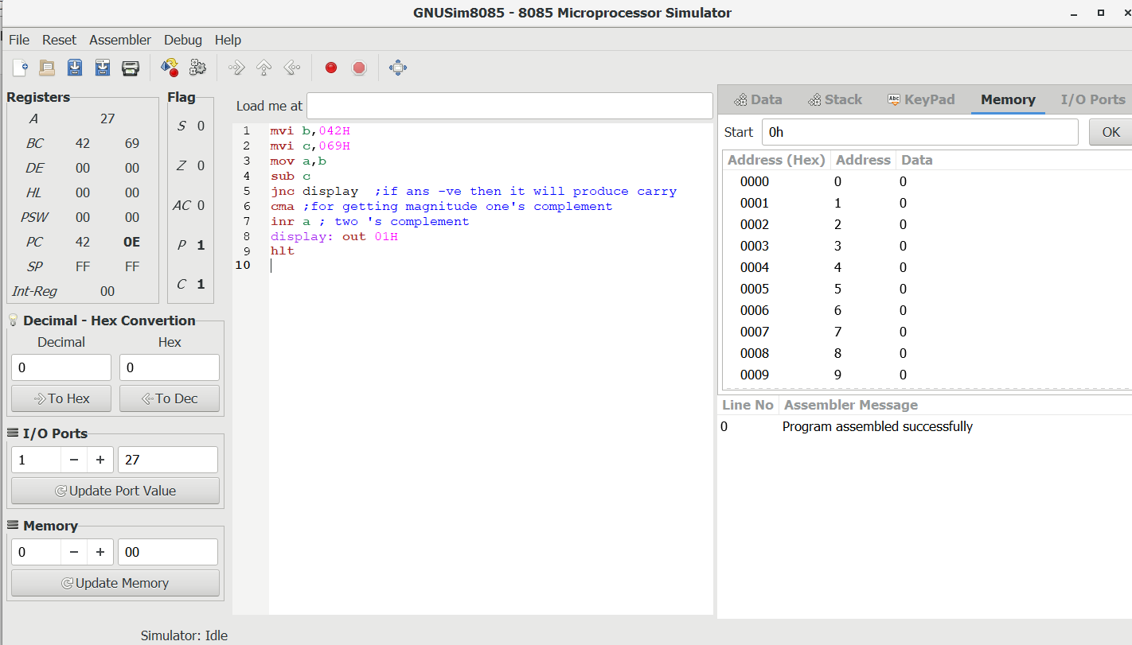

B. Set2:B=69H,C=42H

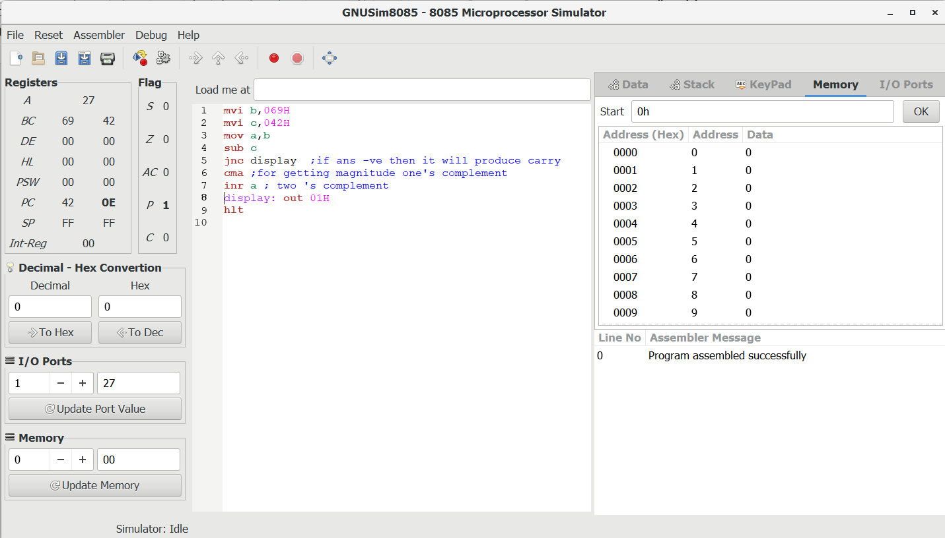

C. Set 3: B=F8H,C = 23H

